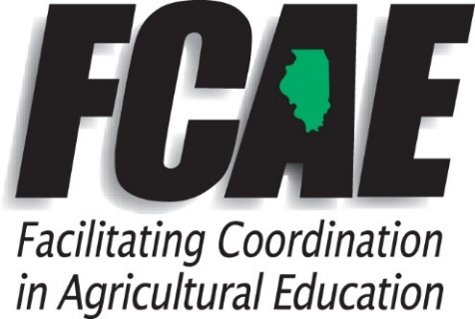
Lucas Allen
Agriculture Education Program Advisor
2015 Manchester Rd
Wheaton, IL 60187
(C) 815-530-2065
lallen@ILAgEd.org

2020 Summer IAVAT Meeting

District II FCAE Report Agenda
- Retirements
- Kevin Price- Milford

- Surviving Their First Year in D2
- Kaitlyn Post- Burlington Central
- Dayna Anderson- DeKalb
- Amanda Anderson- Gary Comer Youth Center
- Angie Viands- Gary Comer Youth Center
- Kirsten Raver- Rolling Meadows
- Nolan Moss- Naperville Central
- Alexandria Pledger- CHSAS (Foods)
- Alexandra Flory- CHSAS (Business)

- New Teachers* or Moving Schools

- Kade Hill* Milford
- Jenna Baker* Tri-Point
- Courtney Wiedenmann* Sycamore
- Cally Diss* Marquette Academy
- Hannah Weinzierl- El Paso-Gridley
- Parker Bane- Normal West
- Sara Jane Caise- St. Anne
- Wendy Ochs- Iroquois West
- Jessica Bochniak- Somonauk

- New D1 FCAE Program Advisor
- John Heiser- Office will be located in Princeton, IL. Email is jheiser@ilaged.org

- Incentive Funding and Three Circles Grant

- All FY20 Grants have been extended through June 30, 2021
- Information regarding FY21 Grants is forthcoming from ISBE
  - Be on a lookout for an email
- Grant Resources can be found here:
  - https://www.isbe.net/Pages/Agriculture-Education.aspx
- If you need assistance with completing your application, budget, or reports, please let me know.

- FCAE Professional Development
- Check out summer Professional Development Opportunities here
  - https://www.ilaged.org/professional-development

- Illinois Ag Teacher Retention Survey
- Please take a few minutes to fill out this survey to help us collect data on Teacher Retention. This was sent out via email from Jay Solomonson on 6/1/20.

- Virtual Ag Department Tours & Field Trips from NAAE

